Wave Packets
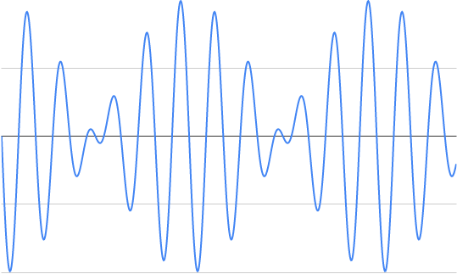
The eigen state function O (x) represents a classically (localized) particle as a wave packet. The name wave packet is derived from the shape of the graph for the wave function (w). Such a state is constructed as a sum of eigen states O (x), [1], using the exponential representation of standing wave equation, [2].
The wave packet represents where you can find the particle as it travels through your detector.
The state function O (x) of the form N Dirac [L] (x), [4], goes to zero, as (L) approaches infinity everywhere except when (x) equals zero, [5 - 6]. At the other extreme, a plane wave, [4] has a constant modulus, absolute value of the state function O (x), is (N) at every point along the x-axis from negative to positive infinity, [8 - 9]. A wave function (w) which interpolates between these two extreme cases is the ‘Gaussian wave packet’, [10].
A Gaussian damping factor (a) is used to modulate a plane wave. As (a) goes to zero, at fixed momentum (p0), this wave function is proportional to Dirac Delta function δ [L] (x) (where L = 1/2 a 2 ), while (a) goes to infinity, the state function O (x) approaches a plane wave.

Integration Techniques
Wave packets provide a very useful example of how the wave function of a free particle evolves in time, and for this purpose we make use of the Gaussian integration formulas.

Localized Wave Packets

Gaussian Wave Packets

Motion of Wave Packets

